软件需求工程
实验指导书

西北工业大学软件与微电子学院

第一部分 软件需求工程实验计划及总目标
课程名称：软件需求工程(Software Requirements Engineering)；
实验总学时： 16 学时（4*4）；
适用专业：软件工程；
先修课程：面向对象程序设计、软件工程概论。
一、实验计划及总目标
软件需求工程实验是《软件需求工程》课程中一项重要的实践环节，其目的在于贯彻以理论指导实际的教学原则，通过实验帮助学生在理解软件需求工程的过程、方法、工具的基础上，学习掌握实际软件项目中的需求分析和需求管理，从而提高学生运用CASE工具进行软件需求分析和管理的能力。
软件需求工程实验的任务主要有四项：（1）让学生掌握应用软件分析、设计和实现的基本过程；（2）帮助学生掌握应用软件工程的分析、设计、实现的方法；（3）让学生了解应用软件系统开发的一般过程；（4）让学生学习使用CASE工具。
二、实验环境
PC机、Windows操作系统、UML、Rose、Rational等工具软件。
三、实验方式与基本要求
- 实验方式：指导教师先介绍实验内容和实验中的注意事项，然后学生根据课堂讲授知识分析实验题目、熟悉相关内容、搭建环境、完成实验内容、编写、完成实验报告。
- 基本要求：
包括UML建模、需求获取、需求分析、需求文档、需求管理等几个部分，要求学生根据实际项目的要求，应用传统的结构化方法或者面向对象方法进行需求分析。推荐使用UML和Rational Rose对需求进行分析；根据实际项目的要求，应用项目管理的一般方法或者需求管理的专用方法，对实际系统的需求进行管理；推荐使用Rational RequsitePro工具进行需求管理。
- 实验报告基本要求
实验报告内容的完整性。实验报告内容包括实验目的、实验内容、实验程序、实验结果、实验总结（通过实验学到了什么、遇到的出错及修改过程等）。书写规范、工整。
四、实验项目及教学安排
序号 | 实验项目 | 学时 | 实验内容和基本要求 | 实验类型 | 备注
1 | 需求获取与用例建模 | 4 | 假设你作为一个新的项目的负责人，你需要通过“问题描述”来定义系统的需求，要为需求定义一个用例模型。要确定参与者和用例，并开发出用例图。 | 设计型
2 | 需求分析 | 4 | 通过RU 金融信息案例分析，使用特定的分析方法（鱼骨图等）来查找问题发生的根源。你作为RU e-st项目的负责人，要证实股票交易系统是解决商业问题和帮助实现商业目标的最好的解决方案。带领你的团队通过问题分析来找到问题发生的根源。 | 设计型
3 | 需求文档 | 4 | 检查在线股票交易系统的需求规格说明，存在哪些不足，会导致开发者和用户的误解？查找、标记和记录可能的需求，确认新的参与者，并结合需求分析给出改进的需求规格说明书。 | 综合型
4 | 需求评审 （大作业） | 4 | 学生每4人一组组成项目小组，选择一个实用型开发项目，其用户类不少于4类（系统用户除外），按照《软件需求工程》课程所介绍的有关需求开发过程和方法，完成所选项目的需求开发。 | 综合型 | 分组完成
五、考核方式及成绩评定
- 考核以实验平时考核和实验报告相结合的方式进行。
- 实验成绩评定方法：学生实验成绩的评定都必须按照实验的要求，以实际实验能力的强弱作为主要依据。
六、实验教材、参考书：
教材：
软件需求工程(软件工程系列规划教材), 康雁等, 科学出版社, 2014
实验参考书：
学生实验内容_IBM需求开发与管理实验.pdf
其他参考书：
需求工程——软件建模与分析,骆斌、丁二玉,高等教育出版社, 2015 年2月
软件需求工程原理和方法, 金芝 编, 科学出版社, 2010年2月
需求工程-基础、原理和技术, [德] Klaus Pohl 编；彭鑫 等 译,机械工业出版社,2012年
软件需求管理用例方法(第2版)，（美）莱芬韦尔 等著，蒋慧译，中国电力出版社，2004年05月。

第二部分 实验部分

实验一 需求获取与UML建模
1.实验目的
- 了解需求开发阶段在业务领域对系统建模的重要性；
- 掌握获取和确立业务需求的技术和方法；
- 掌握业务需求建模的模型表示法和相应的文档编写方法；
2.预习与实验要求
- 预习实验指导书及教材的有关内容，了解业务需求的概念及重要性；
- 掌握获取和分析业务需求的方法；
- 实验前认真听讲，服从安排，尽可能独立思考并完成实验。
3.实验原理
- 通过业务需求定义产品前景；
- 业务需求与用例；
- 业务需求在前景与范围文档中的地位；
- 业务需求获取与建模的方法；
4.实验内容 ：
1 确定参与者和用例
本实验的目的在于，在一个虚拟的项目中确定参与者和用例。你将参与到在线课程注册系统的案例并进行案例分析，首先确定系统的参与者，“学生“是一个确定的参与者，在该系统中与哪些成员进行互动呢？对于每一个参与者，请确定其与系统进行交互的类型，其中包括确定用例和为用例命名的规则等。完成下列工作：
- 确定与系统交互的参与者
- 确定用例
- 画出系统的用例图
You have just been assigned the job of lead system analyst for a new system. You have been given a problem description (“Initial System Requests” below). Your first task is to understand the requirements for the new system. From the Initial Requests, you develop a use-case model of the requirements. In this first part of the modeling process, you identify actors and use cases and develop a use-case diagram. As you look at the initial requests for the system, note that the requirements are far from complete. Note what assumptions you make, as well as what other information you want to ask your customer.
Directions:
1. Read the Initial System Requests document.
2. Draw the use-case diagram on easel paper or the board.
• Show actors, use cases, and communicates-associations.
3. Compare the diagram with the sample solution.
4. Discuss the “Discussion Topics” at the end of this exercise.
Wylie College is planning to develop a new online Course Registration System. The new Web-enabled system replaces its much older system developed around mainframe technology. The new system allows students to register for courses from any Internet browser. Professors use the system to register to teach courses and torecord grades.
Because of a decrease in federal funding, the college cannot afford to replace the entire system at once. The college will keep the existing course catalog database where all course information is maintained. This database is an Ingres relational database running on a DEC VAX. The legacy system performance is poor, so the new system accesses course information from the legacy database but does not update it. The registrar’s office continues to maintain course information through another system. Students can request a printed course catalog containing a list of course offerings for the semester. Students can also obtain the course information online at any time. Information about each course, such as professor, department, credit hours, and prerequisites assists students in making informed decisions. The new system allows students to select four course offerings for the coming semester. In addition, each student indicates two alternate choices in case the student cannot be assigned to a primary selection. Courses have a maximum of ten and a minimum of three students.
The registration process closes on the first or second day of classes for the semester. Any course with fewer than three students enrolled on the day registration closes is cancelled. All courses without an instructor on the day registration closes are cancelled. Students enrolled in cancelled classes are notified that the course has been cancelled, and the course is removed from their schedules. The registration system sends information about all student enrollments to the Billing System so that the students can be billed for the semester. For the first two weeks of the semester, students are allowed to alter their course schedules. Students may access the online system during this time to add or drop courses. Changes in schedules are immediately sent to the Billing System so that an updated bill can be sent to the student. At the end of the semester, the student can access the system to view an electronic report card. Since student grades are sensitive information, the system must employ security measures to prevent unauthorized access. All students, professors, and administrators have their own identification codes and passwords. Professors must be able to access the online system to indicate which courses they want to teach. They also need to see which students signed up for their course offerings. In addition, professors can record the grades for the students in each class.
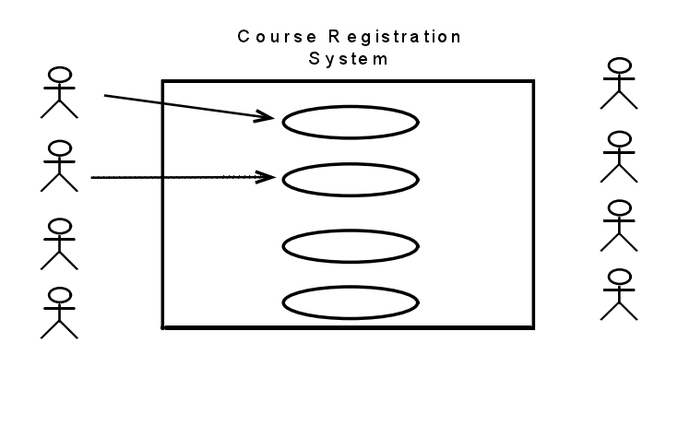
1.确定参与者。（谁使用该系统？谁从系统中获取信息？谁为系统提供信息？谁来维护该系统？还有哪些系统会用到该系统？）
2确定用例。（.每个参与者使用该系统的目的是？各个参与者会创建、存储、修改、或者读取系统中的数据吗？参与者需要告诉系统外部的事件或者更改吗？参与者需要告诉系统突发事件吗？这个系统能够提供所有的正确事件吗？）
5.实验报告
- 详细描述实验的过程和步骤；
- 详细填写完成实验的收获和得失，实验过程中遇到的问题、解决的办法、实验心得以及对该实验的建议和意见。

实验二 需求分析
1.实验目的：
- 掌握需求开发阶段需求的获取和分析的技术和方法；
- 掌握对获取和分析的需求进行建模的方法，掌握建模的基本图形表示法；
- 能把需求获取和分析方法运用到实际的系统分析中，并能运用建模工具和模型记录结果；
2.预习要求：
- 预习实验指导书及教材的有关内容，掌握软件需求基本概念，能运用需求获取和分析的技术和方法对实际的系统进行分析；
- 掌握需求分析的建模方法，熟悉建模工具；
- 运用建模工具和需求获取分析方法对实际系统进行分析，并记录结果；
- 实验前认真听讲，服从安排。尽可能独立思考并完成实验。
3.实验内容：
- 熟悉和掌握UML和Rational Rose工具的使用。在rose中创建新的模型，分别画出如下的图：用例图、类图、包图、活动图、顺序图、状态图等。
- RU 金融信息系统案例
练习4.1 本练习中，首先请熟悉RU金融信息系统，该案例在本课程中作为一个提供需求分析和管理的经典案例。实验的目的在于应用需求分析技术，确定在项目领域中可能出现的隐藏的问题，因为不是每一个问题都能够在一开始就表现的很明显。
目标：熟悉RU金融信息系统项目的细节。
学习如何通过问题分析技术来寻找一个问题产生的根源。
通过RU 金融信息案例分析，使用特定的分析方法（鱼骨图等）来查找问题发生的根源。假设你作为RU e-st项目的负责人，要证实股票交易系统是解决商业问题和帮助实现商业目标的最好的解决方案。带领你的团队通过问题分析来找到问题发生的根源。
方法：通过鱼骨图的方法来确定问题发生的根源。
        - 使用鱼骨图进行问题分析。
        - 确定该问题的最大可能的导致因素。
        - 讨论所提出的方案是不是真正的最优方案。
        - 将你的解决方案与示例方案进行比较。
Business Problem:
RU Financial Services is an investment management organization with 500 offices located across every state. The head office is located in the nation’s capital. RU Financial Services was the first to market with online stock trading in 1992. The personal stock trading business exceeded all expectations and became a significant part of RU Financial Services’ revenue for the next eight years. Since then the company has had difficulty attracting new customers to their service, and existing customers have been switching to rival companies at an alarming rate.
The goal is to see how RU Financial Services can regain its market share and continue to grow the personal stock trading side of the business. The board members have done some analysis and decided that the current stock trading system needs replacing. Harold Smedley, the Vice-President of RU Financial Services, has asked you to determine if this truly is the best course of action.
• Based on a recent customer satisfaction survey, 60% of customers were not satisfied with how long it took for updates to the software to become available. This dissatisfaction figure needs to be reduced to less than 5%.
• The current business model for RU Financial Services mandates that infrastructure costs should not be more than 10% of the revenue generated by the business. This is currently running at 40%.
• Maintenance costs of the software are currently running at 25% above the average maintenance costs of other software in the company. This figure must be reduced to no more than 15%.
• Based on a recent survey, it was found that 70% of customers require additional services that the current system does not provide. The main requests were: real- time stock quotes; ability to research stock, ability to fund trading account directly from a savings account held in another financial institution, and Web access instead of having to install client software.
• About 2% of customers have experienced errors in their trades in the last six months. This figure must be reduced to 0%.
The Business Background:
RU Financial Services introduced their online trading system in 1992 before the birth of e-commerce. At that time, the company had a corporate standard architecture of VAX 6300 mainframe computers and DECstation 3100s for desktop machines. For this project, the company chose to use a VAXft 3000, DIGITAL’s first fault tolerant machine. The new corporate standard for desktops is a standard PC running Microsoft Windows 2000. The server standard is a high-end PC running Windows 2000 Server or an IBM eServer iSeries 890.
The current stock trading system employs a client-server architecture. Updates to the software are mailed to the customer for installation bi-annually. Critical bug fixes are sent out on demand. The customer is required to install the client software on a machine running Microsoft Windows 98 or higher or an Apple running Mac OS X.
The client software is written in QuickBasic and runs in a console window. The client software communicates with a server application via a 56K dial-up connection. The server application runs on a VAXft 3000. The server software is written in COBOL and comprises 500,000 lines of code. The server application is the last application that runs on a VAXft 3000. All other corporate applications have been migrated to the new corporate standard platform. The VAXft 3000 is under a 24x7 maintenance contract. The cost of the maintenance contract is $200,000 per annum.
The company phased out the systems written in COBOL and QuickBasic some years ago. All software in the company is written one of the following: C++, Java, or Visual Basic. Due to the success of the system, the company did not want to rewrite the stock trading system and risk the introduction of bugs and loss of revenue. The current stock trading system is the only system that uses COBOL and QuickBasic.
The company has adopted the Rational Unified Process for developing and maintaining all systems in the organization. All projects are required to use this process. The company mentor for the RUP is Kelly Richardson. There is no existing documentation for the client or server applications. None of the original development team remains employed at the company; therefore, contract programmers maintain the software. As a result, the code for both the client and the server has become very unstructured and fragile. Recently, this has caused some major bugs that have caused errors in trades and required multiple updates to the client and server software.
A dedicated testing group performs testing of the system. Because the system runs in a console window on the client PC, the testers are unable to use their automated testing software. The test scripts are performed manually. New tests are rarely designed because they are document based.
Current System Architecture:
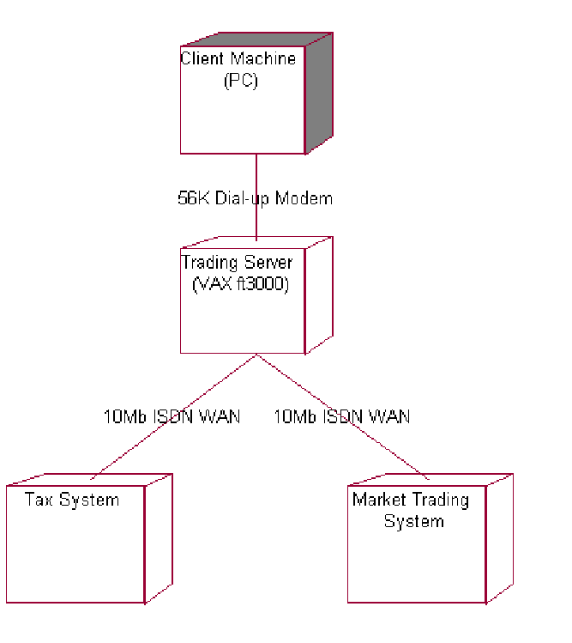
练习4.2描述问题
本练习的目的是，描述问题并描述解决方案的边界。
理解你的项目中所有的利益相关者以及付费的用户，确保你考虑到所有的影响结果的因素，包括系统维护者，开发者等。
目标：
- 确定项目中的利益相关者
- 确定与系统相关的参与者
- 使用标准的问题描述格式来为项目形成问题的声明。
Part 1: Identify Stakeholders (Section 3.2 of the Vision document)
Using the Vision document included in your student pack, complete Section 3.2:
Stakeholder Summary:
Who are the key stakeholders for the class problem?
Who are the stakeholders that will actually be using the system (potential actors)?
Which stakeholders will you seek to obtain requirements from? For the stakeholders that are not sources of requirements, what should you do with them?
All users of the system are stakeholders because they are materially affected by the system. But there are some stakeholders (for example, stockholders) who are probably not actors because they will never use the system.
Part 2: Identify Actors and Boundaries
An actor is a user of the system. A user can either be an individual or an external system. By definition, an actor is outside of the system, therefore; identifying the actors helps to define the boundaries of the system.
Label some of the actors in the diagram below. Use the following questions to help you determine if you have found them all. Refer back to the business background in Exercise 4.1 to help you identify your initial list of actors.
Actors
• Who uses the system?
• Who gets information from the system?
• Who provides information to the system?
• Where in the organization is the system used?
• Who supports and maintains the system?
• What other systems use this system?
Boundaries
• What are the interfaces to outside systems for our project?
• How can use cases help us figure out these boundaries?
• What is part of the system?
• What is not part of the system?
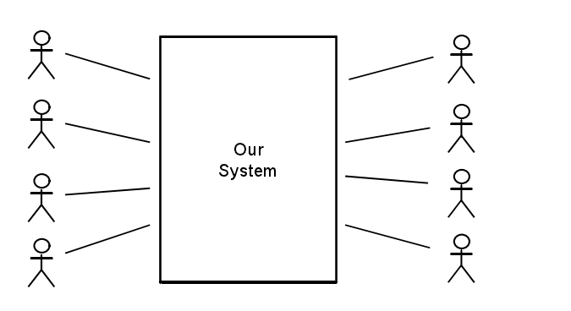
Part 3: Identify Constraints (Section 6 of the Vision document)
Complete Section 6: Constraints of the Vision document.
What types of constraints might you encounter in your class project?
Part 4: Problem Statement (Section 2.2 of the Vision)
Complete Section 2.2: Problem Statement of the Vision document.
The problem statement table is a tool for gaining agreement on the problem being solved. This is a simple technique to help articulate the problem and to ensure that everyone agrees on the problem. Fill in the problem statement table for your class project.
Below is a copy of the template and an example to help you get started.
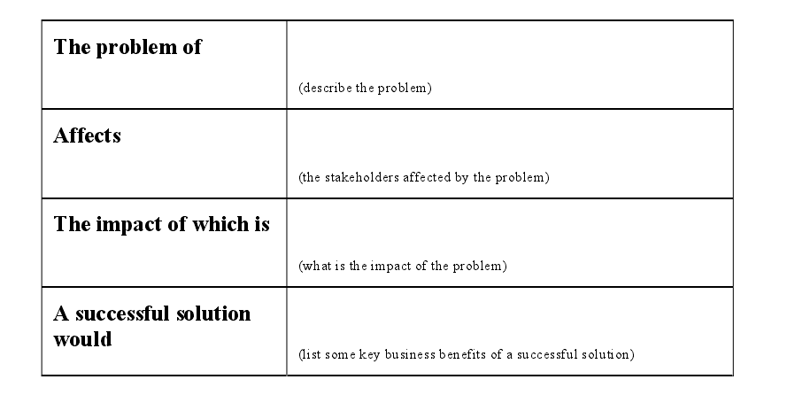
4.实验步骤：
- 根据问题目标、业务背景、问题陈述（描述）等，确定系统的参与者Actor（用户），确定系统相关功能用例，做出用例图。
- 使用鱼骨图去查找问题发生的根源。

实验三 需求文档
1.实验目的
- 掌握需求开发中从业务需求、用户需求到功能性和非功能性需求的逐步细化的需求获取技术和方法；
- 掌握需求规格说明书(SRS)的编写；
- 掌握对系统最终的需求用需求规格说明文档进行描述的方法；
2.预习与实验要求
- 预习实验指导书及教材的有关内容，了解需求规格说明文档的编写规范及模板；
- 掌握需求规则说明文档的内容，掌握需求细化，逐步分析获取的方法；并能把细化分析的需求编写到规格说明文档中；
- 实验前认真听讲，服从安排，尽可能独立思考并完成实验。
3.实验原理
- 软件需求规格说明，需求标识；
- 需求细化分析的方法及完善模型的技术；
- 软件需求规格说明模板；
- 编写需求文档的原则；
4. 实验内容
1.检查并改进用户需求规格说明书
本练习中，从系统需求中确定并逐项记录需求，这是在线股票交易系统的系统需求规格说明书。练习的目的是，为了使学生能够熟悉传统格式的需求文档，并逐渐能够确定派生的需求。
In this exercise, you do the following tasks:
Review the Online Stock Trading System Specifications.
Look for possible requirements.
Mark and number each requirement.
Refine the solution boundary by revisiting the list of actors.
Review a sample list of stakeholder requests.
Update the Vision with the stakeholder needs you have identified. (optional)
练习目标：
      - 检查在线股票交易系统的规格说明书（P27）。
      - 查找其他可能的需求。
      - 标记并为需求进行计数。
      - 通过重新访问参与者的列表来提炼解决方案的边界。
      - 回顾利益相关者请求的示例列表。
      - 改进该需求规格说明书。
第一部分 （分组完成）
- 找到在线股票交易系统的初始需求（注意该需求是不完整的）
- 读一遍需求规格说明书（P27）。
- 标记任何你认为是软件需求的部分。
- 改进该软件需求规格说明书。
第二部分（分组讨论）
- 列出所有你找到的需求
- 比较不同成员找到的需求的数量的差异。
- 集体讨论。讨论的问题包括：
为什么会有数量的差异？如何处理这些差异？
标准化文档的好处有哪些？需求的鉴定方法有哪些？
当你从用户那里获取到一个需求时，你怎样处理？
你的参与者列表是否发生变化？
Part 2: ReIn this exercise, familiarize yourself with the list of sample stakeholder requests. This list is used to illustrate traceability in subsequent exercises.
Note: The following is a sample list of stakeholder requests that were produced during the workflow detail of Understand Stakeholder Needs. This list is included so that the traceability from stakeholder requests to features and use cases can be illustrated. The list is not intended to be exhaustive and there any many other stakeholder requests that you may have elicited.
1. Review the list of sample stakeholder requests. (This is used as input into the next exercise.)
2. List the needs in section 3.7 of your Vision document (Optional).
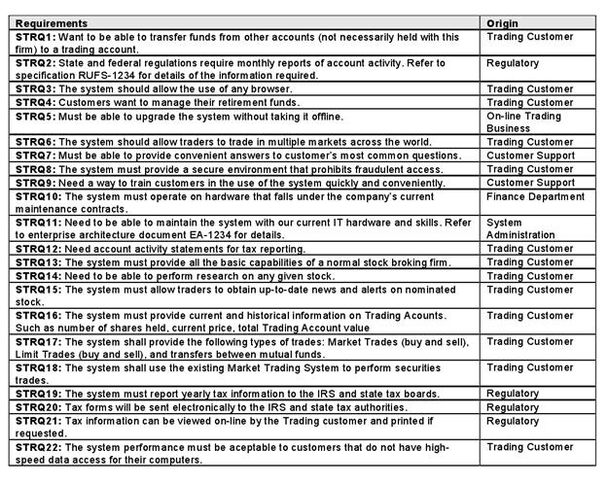
Brainstorming
• Try brainstorming as a requirements elicitation technique.
• Update the Vision document with the needs you identify.
As project lead, you need to identify the needs of the stakeholders for your new system. You have called your stakeholders together for a brainstorming session.
Remember: The needs you identify must help solve the business problem. If they do not, why have them?
To do this exercise, put yourself in the shoes of the stakeholders. Consider what they need from the system.
All stakeholders have all been trained on the rules of brainstorming:
• Clearly state the objective of the session.
• Generate as many ideas as possible.
• Criticism and debate are not allowed.
• Change and combine ideas.
2.确定系统特征
1）本练习中，更新描述文档；在股票交易系统的案例中，讨论系统特征，并写出一个职位的声明，在项目中列出所有的特征。
As project lead, you are responsible for the Vision document for your project. Your team has been working to describe the problem and how to address it, identify stakeholders and users, elicit stakeholder/user needs, identify key product features, and recognize constraints. Now, formalize this information in your Vision document.
分组讨论（问题的描述；利益相关者和参与者；鱼骨图；关键利益相关者和用户需求；约束条件）
讨论一些产品特征：查看利益相关者的请求；对于每个请求，确定一些你打算包含在系统描述中的关键特征；给每个特征一个需求标签；
Things To Consider
• Are there any stakeholder requests that do not trace to one or more features? What should you do in this situation?
• How does the Product Position Statement differ from the Problem Statement? Why is it useful to have both of them in your Vision document?
• How does viewing the results of putting together a Vision document influence your perception of your project?
写出一个产品职位清单
The product position statement is a tool for communicating the intent of the application and the importance of the project to all concerned personnel.
Complete the product position statement table for your class project. Refer to the Vision document for further instructions. Below is an example to help you get started.
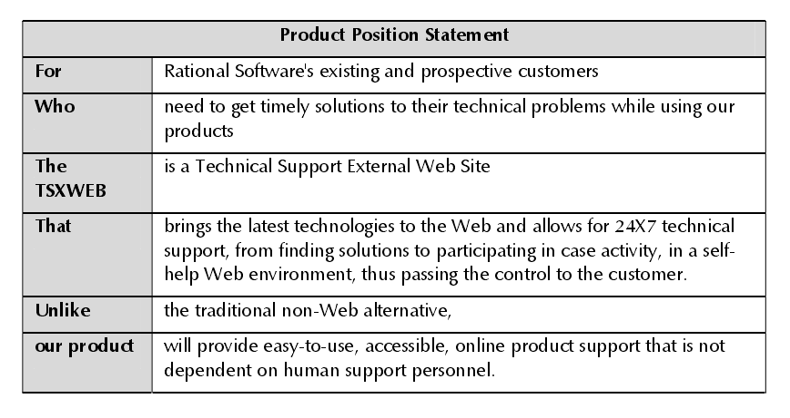
2）确定用例
确定了该项目的参与者和用例之后，请画出用例图.
In this exercise, complete the following tasks:
Identify the use cases for the system.
Create a brief description of the selected use cases.
Create a use-case diagram for the system.
作为项目负责人，你希望从用户的角度来理解该系统，了解用户期望使用该系统来完成什么。整理一下你所收集的信息，并建立需求的用例模型。在用例建模的过程中，确定用例，并为每个用例写一个简要的描述，接下来为用例建立一个详细的描述文件。当你查看系统的初始请求和其他信息时，你也许会感觉到，需求还是远远不完备的，记录下你的想法和你打算咨询客户的问题。
Identify Use Cases
What are the goals of each actor?
• What will the actor use the system for? Will the actor create, store, change, remove, or read data in the system? why?
• Will the actor need to inform the system about external events or changes?
• Will the actor need to be informed about certain occurrences in the system?
Does the system supply the business with all of the correct behavior?
Draw the Use-Case Diagram
Draw a use-case diagram for the class project.
Discussion Topics
How does your solution compare with the sample solution? What is different? What is the same?
Are the use cases too small? Should some use cases be combined?
Does the brief description provide a good overview of the use cases purpose? Is there too much detail, not enough detail, or just enough detail?
Does the diagram cover all activities? Can you think of any activities not covered?
How do you know what is done in each use case?
Does your use-case model satisfy the goals of all stakeholders?
Did you identify any new actors?
R-U est系统 需求规格说明书：
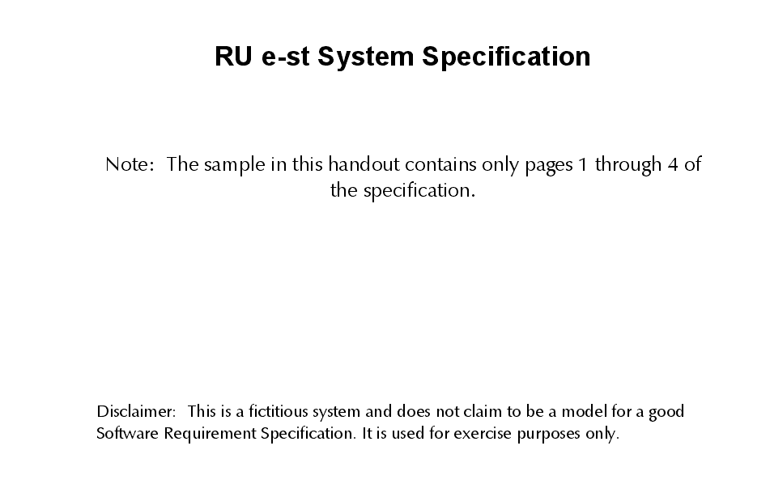
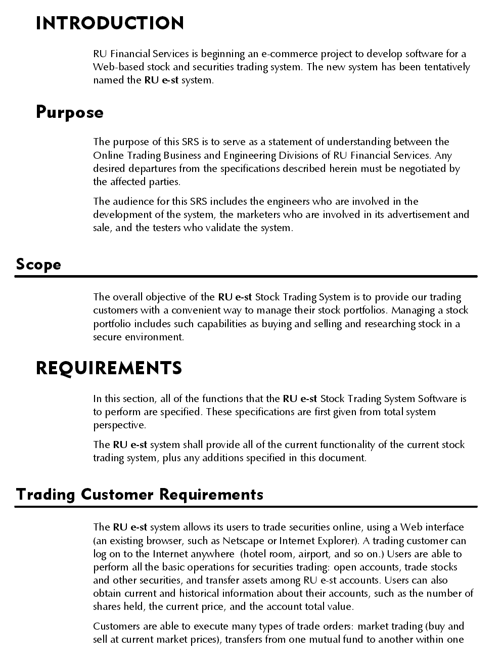
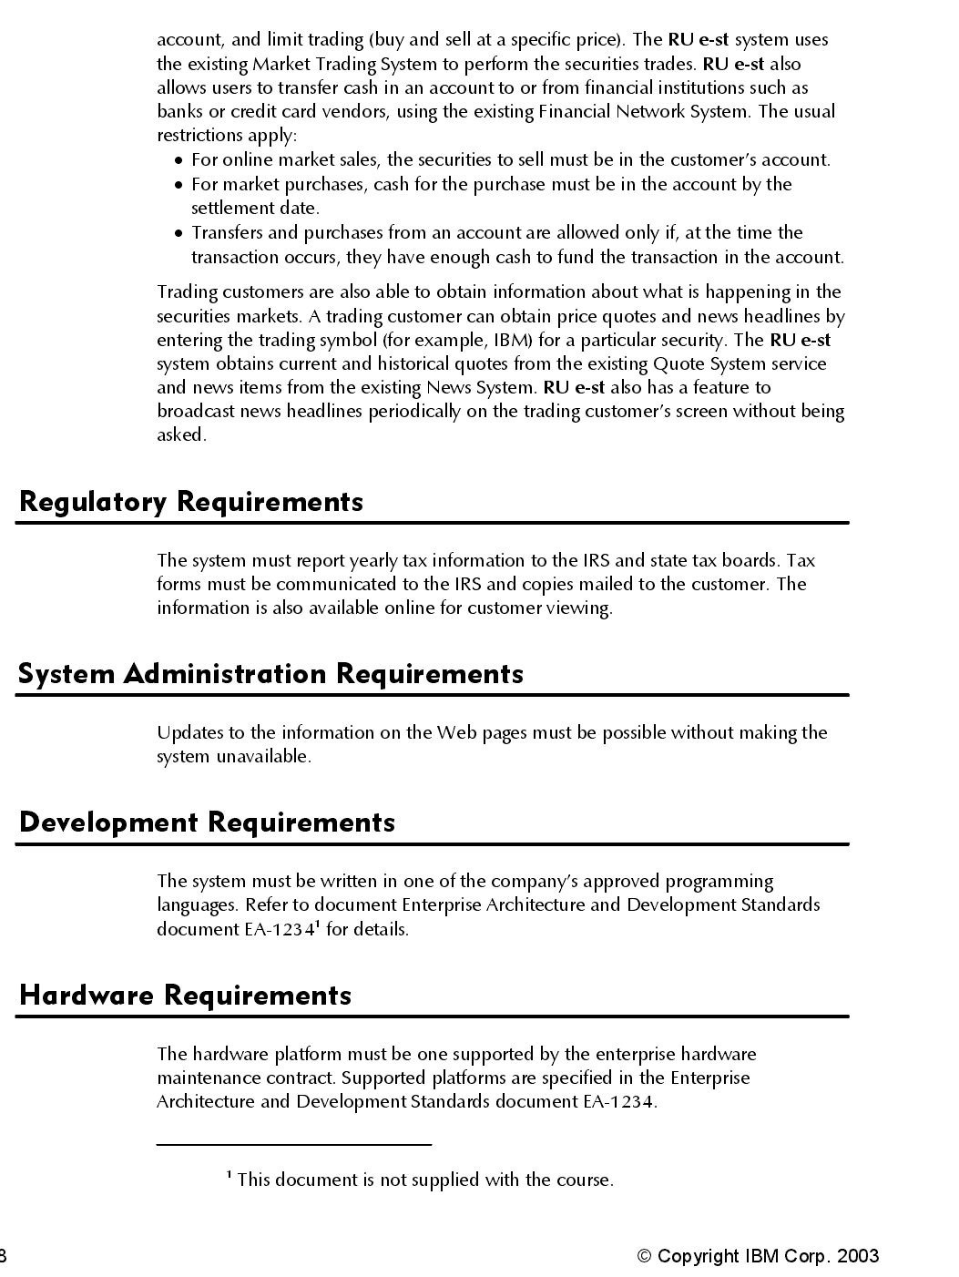

实验四 需求评审（大作业中需求文档评审）
《软件需求工程》大作业要求
学生每4人一组组成项目小组，选择一个实用型开发项目，其用户类不少于4类（系统用户除外），按照《软件需求工程》课程所介绍的有关需求开发过程和方法，完成所选项目的需求开发。主要工作和交付成果包括：
- 进行业务需求分析，按照模板（见附件1）书写《项目视图与范围文档》；
- 分析项目的用户类及其特征，撰写《用户特征分析报告》，画出《系统关联图》；
- 完成项目需求获取和需求分析，按照模板（见附件2或附件3）书写项目《软件需求规格说明书》（1.0版）；
- 小组间进行《软件需求规格说明书》的审查，做好审查过程计划和实施，记录审查过程，书写《问题列表》；
- 分析《问题列表》中的有关问题，进行需求文档修改和完善，形成《软件需求规格说明书》（2.0版）。最终的需求文档中，非功能需求不得少于总需求项的20%。
附件1 项目视图与范围文档
1. 业务需求
业务需求描述了新系统将带给投资人、购买者和用户的主要利益。不同类型的产品，例如信息管理系统，商业软件包和实时控制软件将有不同的侧重点。然而，项目开发的投入是由于人们坚信：有了新产品，世界将变得更加美好。本部分描述了你为什么要从事此项目的开发，以及它将给开发者和购买者带来的利益。
1.1 背景
概述新产品的来由与背景。对历史和现状进行概括性的描述，说明为什么决定开发该产品。
1.2 业务机遇
如果开发的是商业产品，则描述存在的市场机遇以及产品要参与竞争的市场。如果是企业信息系统，则应描述要解决的业务问题或需要改进的业务流程，以及系统的应用环境。还应对已有的产品和可能的解决方案进行比较评估，指出新产品的优点。说明有哪些问题因为没有该产品而在当前无法解决，并说明该产品为什么具有吸引力和它们所能带来的竞争优势。认识到目前只能使用该产品才能解决的一些问题，并描述产品是怎样顺应市场趋势和战略目标的。
1.3 业务目标与成功标准
用一个定量和可测量的合理方法总结产品所带来的重要商业利润。关于给客户带来的价值在本模板1.5的项目视图和范围文档中阐述，这里仅把重点放在给业务的价值上。这些目标与收入预算或节省开支有关，并影响到投资分析和最终产品的交付日期。如果这些信息在其它地方已叙述，就请参考有关文档，在此就不再重复了。
1.4 客户或市场需求
描述一些典型客户的需求，包括不满足现有市场上的产品或信息系统的需求。提出客户目前所遇到的问题在新产品中将可能(或不可能)出现的阐述，提供客户怎样使用产品的例子。确定了产品所能运行的软、硬件平台。定义了较高层次的关键接口或性能要求，但避免设计或实现细节。把这些要求写在列表中，可以反过来跟踪调查特殊用户和功能需求。
1.5 提供给客户的价值
确定产品给客户带来的价值，并指明产品怎样满足客户的需要。可以用下列言辞表达产品带给客户的价值：
- 提高生产效率，减少返工。
- 节省开支。
- 业务过程的流水线化。
- 先前人工劳动的自动化。
- 符合相关标准和规则。
- 与目前的应用产品相比较，提高了可用性或减少了失效程度。
1.6 业务风险
总结与开发该产品有关的主要业务风险，例如市场竞争、时间问题、用户的接受能力、实现的问题或对业务可能带来的消极影响。预测风险的严重性，指明你所能采取的减轻风险的措施。
2. 项目视图的解决方案
文档中的这一部分为系统建立了一个长远的项目视图，它将指明业务目标。这一项目视图为在软件开发生存期中作出决策提供了相关环境背景。这部分不应包括详细的功能需求和项目计划信息。
2.1 项目视图陈述
编写一个总结长远目标和有关开发新产品目的的简要项目视图陈述。项目视图陈述将考虑权衡有不同需求客户的看法。它可能有点理想化，但必须以现有的或所期待的客户市场，企业框架、组织的战略方向和资源局限性为基础。核心内容包括：
- 目标客户
- 需求或机遇说明
- 产品名称
- 产品类别
- 主要竞争产品、当前系统或当前业务过程
- 新产品的主要竞争优势
2.2 主要特性
包括新产品将提供的主要特性和用户性能的列表。强调的是区别于以往产品和竞争产品的特性。可以从用户需求和功能需求中得到这些特性。
2.3 假设与依赖环境
在构思项目和编写项目视图和范围文档时，要记录所作出的任何假设。通常一方所持的假设应与另一方不同。如果你把它们都记录下来，并加以评论，就能对项目内部隐含的基本假设达成共识。比如，“化学制品跟踪系统”的开发者假设：该系统可以替代现有的仓库存货系统，并能与有关采购部门的应用相连接。把这些都记录下来以防止将来可能的混淆和冲突。还有，记录项目所依赖的主要环境，比如：所使用的特殊的技术、第三方供应商、开发伙伴或其它业务关系。
3. 范围与限制
当一个化学家发明了可以把一种化学制品转变为另一种化学制品的新的化学变化时，它所发表的论文中包含了“范围和局限性”部分，这一部分描述了这一化学变化所能作和不能作的一种限定。类似地，一个软件项目也必须定义它的范围和局限性，并作为业务需求的一部分。
项目范围定义了所提出的解决方案的概念和适用领域，而局限性则指出产品所不包括的某些性能。澄清范围和局限性这两个概念有助于建立各风险承担者所企盼的目标。有时客户所要求的性能过高或者与产品所制定的范围不一致。一般客户所提出的需求超出项目的范围时就应当拒绝它，除非这些需求是很有益的。这时，可适当扩大项目范围来适应这些需求 (在预算、计划、人员方面也要相应进行变化)。记录这些需求以及拒绝它们的原因，以备日后重新遇到时，有记录可查。
3.1 首次发行版本的范围
总结首次发行的产品所具有的性能。描述了产品的质量特性，这些特性使产品可以为不同的客户群(customer community)提供预期的成果。如果你的目标集中在开发成果和维持一个可行的项目规划上，应当避免一种倾向，那就是把一些潜在的客户所能想到的每一特性都包括到首发版本（1．0版本）的产品中。这一倾向所带来的普遍恶果是产生软件规划的动荡性和错误性。开发者应把重点放在能提供最大价值、花费最合理的开发费用及普及率最高的产品上。
例如，一个项目开发小组为用户完成包裹传递业务的首发版软件。1．0版本并不要求快速、结构紧凑或易于使用，但该软件必须稳定运行；整个开发小组始终以这一目标为准。首发版的软件完成了基本的系统目标，而随后的版本则包含了附加的特性、选项和使用帮助。
3.2 各后续发行版本的范围
在一个周期性的产品演变过程中必须指明哪一个主要特性的开发将被延期，并在期待随后的版本中发行。
3.3 假设与排除
明确定义包括和不包括的特性和功能的界线是处理范围设定和客户期望的一个途径。列出风险承担者们期望的而你却不打算把它包括到产品中的特性和功能。
4.业务背景
这一部分总结了一些项目的业务问题，包括主要的客户分类概述和项目的管理优先级。
4.1 涉众简介
涉众（skakeholder）是积极参与项目、受项目结果影响，或者能够影响项目结果的个人、团体或组织。涉众概述明确了这一产品的不同类型客户的一些本质的特点，以及目标市场部门和在这些部门中的不同客户的特征。对于每一种客户类型，概述要包括以下信息：
- 各种客户类型将从产品中获得的主要益处。
- 它们对产品所持的态度。
- 感兴趣的关键产品的特性。
- 哪一类型客户能成功使用。
- 必须适应任何客户的限制。
4.2 项目优先级
要想更有效地进行决策，涉众必须就项目的优先级达成一致。取得这种一致的方法之一是考虑软件项目的五个方面：性能、质量、计划、成本和人员。在所给的项目中，其每一方面应与下面三个因素之一相适应。
激励或驱动(driver）：重要的成功目标，灵活性有限，只能稍作修改。
约束(constraint)：限制因素，项目必须在这些限制下展开工作。
自由度(degree of freedom)：项目经理可根据其他方面进行平衡及调整的因素。
项目经理的目标是：在约束施加的限制内，调整属于自由度的因素，从而获得项目的成功激励。并非所有的因素都能成为激励，也不是所有的因素都是约束因素。当项目的需求或现实条件发生改变时，项目经理需要有一定的自由度才能对其做出适当的反应。
4.3 操作环境
明确产品的成功是如何定义和测量的，并指明对产品的成功有巨大影响的几个因素。不仅要包括组织直接控制的范围内的事务，还要包括外部因素。如果可能，可建立测量的标准，用于评价是否达到业务目标，这些标准的实例有：市场股票、销售量或收入、客户满意程度的测量、交易处理量和准确度。
附件2 软件需求规格说明书

1．引言
引言提出了对软件需求规格说明的纵览，这有助于读者理解文档如何编写并且如何阅读和解释。
1.1目的
对产品进行定义，在该文档中详尽说明了这个产品的软件需求，包括修正或发行版本号。如果这个软件需求规格说明只与整个系统的一部分有关系，那么就只定义文档中说明的部分或子系统。
1.2 文档约定
描述编写文档时所采用的标准或排版约定，包括正文风格、提示区或重要符号。例如，说明了高层需求的优先级是否可以被其所有细化的需求所继承，或者每个需求陈述是否都有其自身的优先级。
1.3 预期的读者和阅读建议
列举了软件需求规格说明所针对的不同读者，例如开发人员、项目经理、营销人员、用户、测试人员或文档的编写人员。描述了文档中剩余部分的内容及其组织结构。提出了最适合于每一类型读者阅读文档的建议。
1.4产品的范围
提供了对指定的软件及其目的的简短描述，包括利益和目标。把软件与企业目标或业务策略相联系。可以参考项目视图和范围文档而不是将其内容复制到这里。
1.5参考文献
列举了编写软件需求规格说明时所参考的资料或其它资源。这可能包括用户界面风格指导、合同、标准、系统需求规格说明、使用实例文档，或相关产品的软件需求规格说明。在这里应该给出详细的信息，包括标题名称、作者、版本号、日期、出版单位或资料来源，以方便读者查阅这些文献。
2. 总体描述
这一部分概述了正在定义的产品以及它所运行的环境、使用产品的用户和已知的限制、假设和依赖。
2.1 产品的前景
描述了软件需求规格说明中所定义的产品的背景和起源。说明了该产品是否是产品系列中的下一成员，是否是成熟产品所改进的下一代产品、是否是现有应用程序的替代品，或者是否是一个新型的、自含型产品。如果软件需求规格说明定义了大系统的一个组成部分，那么就要说明这部分软件是怎样与整个系统相关联的，并且要定义出两者之间的接口。
2.2 产品特性
概述了产品所具有的主要特性和实现的重要功能。其详细内容将在4中描述，所以在此只需要概略地总结，例如用列表的方法给出。很好地组织产品的功能，使每个读者都易于理解。用图形表示主的需求分组以及它们之间的联系，例如数据流程图的顶层图或类图，都是有用的。
2.3 用户类和特征
确定可能使用该产品的不同用户类并描述它们相关的特征。有一些需求可能只与特定的用户类相关。将该产品的重要用户类与那些不太重要的用户类区分开。
2.4 运行环境
描述了软件的运行环境，包括硬件平台、操作系统和版本，还有其它的软件组件或与其共存的应用程序。
2.5设计和实现上的限制
确定影响开发人员自由选择的问题，并说明这些问题为什么成为一种限制。可能的限制包括如下内容：
- 必须使用或者避免的特定技术、工具、编程语言和数据库。
- 所要求的开发规范或标准(例如，如果由客户的公司负责软件维护，就必须定义转包者所使用的设计符号表示和编码标准。
- 企业策略、政府法规或工业标准。
- 硬件限制，例如定时需求或存储器限制。
- 数据转换格式标准。
2.6 假设和依赖
列举出在对软件需求规格说明中影响需求陈述的假设因素(与已知因素相对立)。这可能包括你打算要用的商业组件或有关开发或运行环境的问题。你可能认为产品将符合一个特殊的用户界面设计约定，但是另一个SRS读者却可能不这样认为。如果这些假设不正确、不一致或被更改，就会使项目受到影响。
此外，确定项目对外部因素存在的依赖。例如，如果你打算把其它项目开发的组件集成到系统中，那么你就要依赖那个项目按时提供正确的操作组件。如果这些依赖已经记录到其它文档(例如项目计划)中了，那么在此就可以参考其它文档。
3. 系统特性
本模版是根据系统特性即产品所提供的主要服务来组织的。可通过使用实例、运行模式、用户类、对象类或功能等级来组织这部分内容。还可以使用这些元素的组合。总而言之，必须选择一种使读者易于理解预期产品的组织方案。
仅用简短的语句说明特性的名称，例如“3.1拼写检查和拼写字典管理”。无论你想说明何种特性，阐述每种特性时都将重述从3.x.1—3.x.3这三步系统特性。
3.x.1 说明和优先级
提出了对该系统特性的简短说明并指出该特性的优先级是高、中，还是低。或者你还可以包括对特定优先级部分的评价，例如利益、损失、费用和风险，其相对优先等级可以从1(低)到9(高)。
3.x.2 激励/响应序列
列出输入激励(用户动作、来自外部设备的信号或其它触发器)和定义这一特性行为的系统响应序列。就像以前讨论的那样，这些序列将与使用实例相关的对话元素相对应。
3.x.3 功能性需求
详列出与该特性相关的详细功能需求。这些是必须提交给用户的软件功能，使用户可以使用所提供的特性执行服务或者使用所指定的使用实例执行任务。描述产品如何响应可预知的出错条件或者非法输入或动作。就像本章开头所描述的那样，你必须唯一地标识每个需求。
4. 外部接口需求
利用本节来确定可以保证新产品与外部组件正确连接的需求。关联图表示了高层抽象的外部接口。需要把对接口数据和控制组件的详细描述写入数据字典中。如果产品的不同部分有不同的外部接口，那么应把这些外部接口的详细需求并入到这一部分的实例中。
4.1 用户界面
陈述所需要的用户界面的软件组件。描述每个用户界面的逻辑特征。以下是可能要包括的一些特征：
- 将要采用的图形用户界面(GUI)标准或产品系列的风格。
- 屏幕布局或解决方案的限制。
- 将出现在每个屏幕的标准按钮、功能或导航链接(例如一个帮助按钮)。
- 快捷键。
- 错误信息显示标准。
对于用户界面的细节，例如特定对话框的布局，应该写入一个独立的用户界面规格说明中，而不能写入软件需求规格说明中。
4.2 硬件接口
描述系统中软件和硬件每一接口的特征。这种描述可能包括支持的硬件类型、软硬件之间交流的数据和控制信息的性质以及所使用的通信协议。
4.3 软件接口
描述该产品与其它外部组件(由名字和版本识别)的连接，包括数据库、操作系统、工具、库和集成的商业组件。明确并描述在软件组件之间交换数据或消息的目的。描述所需要的服务以及内部组件通信的性质。确定将在组件之间共享的数据。如果必须用一种特殊的方法来实现数据共享机制，例如在多任务操作系统中的一个全局数据区，那么就必须把它定义为一种实现上的限制。
4.4 通信接口
描述与产品所使用的通信功能相关的需求，包括电子邮件、Web浏览器、网络通信标准或协议及电子表格等等。定义了相关的消息格式。规定通信安全或加密问题、数据传输速率和同步通信机制。
5. 其它非功能需求
这部分列举出了所有非功能需求，而不是外部接口需求和限制。
5.1 性能需求
阐述了不同的应用领域对产品性能的需求，并解释它们的原理以帮助开发人员作出合理竺设计选择。确定相互合作的用户数或者所支持的操作、响应时间以及与实时系统的时间关系。你还可以在这里定义容量需求，例如存储器和磁盘空间的需求或者存储在数据库中表的最大行数。尽可能详细地确定性能需求。可能需要针对每个功能需求或特性分别陈述其性能需求，而不是把它们都集中在一起陈述。例如，“在运行微软Window 2000的450 MHzPentiumⅡ的计算机上，当系统至少有50％的空闲资源时，95％的目录数据库查询必须在两秒内完成”。
5.2 安全设施需求
详尽陈述与产品使用过程中可能发生的损失、破坏或危害相关的需求。定义必须采取的安全保护或动作，还有那些预防的潜在的危险动作。明确产品必须遵从的安全标准、策略或规则。一个安全设施需求的范例如下：“如果油箱的压力超过了规定的最大压力的95％，那么必须在1秒钟内终止操作”。
5.3 安全性需求
详尽陈述与系统安全性、完整性或与私人问题相关的需求，这些问题将会影响到产品的使用和产品所创建或使用的数据的保护。定义用户身份确认或授权需求。明确产品必须满足的安全性或保密性策略。你可能更喜欢通过称为完整性的质量属性来阐述这些需求。一个软件系统的安全需求的范例如下：“每个用户在第一次登录后，必须更改他的最初登录密码。最初的登录密码不能重用。”
5.4 软件质量属性
详尽陈述与客户或开发人员至关重要的其它产品质量特性。这些特性必须是确定、定量的并在可能时是可验证的。至少应指明不同属性的相对侧重点，例如易用程度优于易学程度，或者可移植性优于有效性。
5.5 业务规则
列举出有关产品的所有操作规则，例如什么人在特定环境下可以进行何种操作。这些本身不是功能需求，但它们可以暗示某些功能需求执行这些规则。一个业务规则的范例如下：“只有持有管理员密码的用户才能执行S100.00或更大额的退款操作。”
5.6 用户文档
列举出将与软件一同发行的用户文档部分，例如，用户手册、在线帮助和教程。明确所有已知的用户文档的交付格式或标准。
6. 其它需求
定义在软件需求规格说明的其它部分未出现的需求，例如国际化需求或法律上的需求。你还可以增加有关操作、管理和维护部分来完善产品安装、配置、启动和关闭、修复和容错，以及登录和监控操作等方面的需求。在模板中加入与你的项目相关的新部分。如果你不需要增加其它需求，就省略这一部分。
附录A：词汇表
定义所有必要的术语，以便读者可以正确地解释软件需求规格说明，包括词头和缩写。你可能希望为整个公司创建一张跨越多项项目的词汇表，并且只包括特定于单一项目的软件需求规格说明中的术语。
附录B：分析模型
这个可选部分包括或涉及到相关的分析模型的位置，例如数据流程图、类图、状态转换图或实体—关系。
附录C：待确定问题的列表
编辑一张在软件需求规格说明中待确定问题的列表，对表中每一表项都作了编号，以便于跟踪调查。

软件需求规格说明(SRS)
说明：
1.《软件需求规格说明》(SRS)描述对计算机软件配置项CSCI的需求，及确保每个要求得以满足的所使用的方法。涉及该CSCI外部接口的需求可在本SRS中给出：或在本SRS引用的一个或多个《接口需求规格说明》(IRS)中给出。
2.这个SRS，可能还要用IRS加以补充，是CSCI设计与合格性测试的基础。

附件3： 软件需求规格说明(SRS)

1范围

1.1标识
本条应包含本文档适用的系统和软件的完整标识，(若适用)包括标识号、标题、缩略词语、版本号和发行号。

1.2系统概述
本条应简述本文档适用的系统和软件的用途，它应描述系统和软件的一般特性；概述系统开发、运行和维护的历史；标识项目的投资方、需方、用户、开发方和支持机构；标识当前和计划的运行现场；列出其他有关的文档。

1.3文档概述
本条应概述本文档的用途和内容，并描述与其使用有关的保密性或私密性要求。

1.4基线
说明编写本系统设计说明书所依据的设计基线。

2引用文件
本章应列出本文档引用的所有文档的编号、标题、修订版本和发行日期，也应标识不能通过正常的供货渠道获得的所有文档的来源。

3需求
本章应分以下几条描述CSCI需求，也就是，构成CSCI验收条件的CSCI的特性。CSCI需求是为了满足分配给该CSCI的系统需求所形成的软件需求。给每个需求指定项目唯一标识符以支持测试和可追踪性。并以一种可以定义客观测试的方式来陈述需求。如果每个需求有关的合格性方法(见第4章)和对系统(若适用，子系统)需求的可追踪性(见5.a条)在相应的章中没有提供，则在此进行注解。描述的详细程度遵循以下规则：应包含构成CSCI验收条件的那些CSCI特性，需方愿意推迟到设计时留给开发方说明的那些特性。如果在给定条中没有需求的话，本条应如实陈述。如果某个需求在多条中出现，可以只陈述一次而在其他条直接引用。

3.1所需的状态和方式
如果需要CSCI在多种状态和方式下运行，且不同状态和方式具有不同的需求的话，则要标识和定义每一状态和方式，状态和方式的例子包括：空闲、准备就绪、活动、事后分析、培训、降级、紧急情况和后备等。状态和方式的区别是任意的，可以仅用状态描述CSCI,也可以仅用方式、方式中的状态、状态中的方式或其他有效方式描述。如果不需要多个状态和方式，不需人为加以区分，应如实陈述；如果需要多个状态或方式，还应使本规格说明中的每个需求或每组需求与这些状态和方式相关联，关联可在本条或本条引用的附录中用表格或其他的方法表示，也可在需求出现的地方加以注解。

3.2需求概述

3.2.1目标
a.本系统的开发意图、应用目标及作用范围(现有产品存在的问题和建议产品所要解决的问题)。
b.本系统的主要功能、处理流程、数据流程及简要说明。
c.表示外部接口和数据流的系统高层次图。说明本系统与其他相关产品的关系，是独立产品还是一个较大产品的组成部分(可用方框图说明)。

3.2.2运行环境
简要说明本系统的运行环境(包括硬件环境和支持环境)的规定。

3.2.3用户的特点
说明是哪一种类型的用户，从使用系统来说，有些什么特点。

3.2.4关键点
说明本软件需求规格说明书中的关键点(例如：关键功能、关键算法和所涉及的关键技术等)。

3.2.5约束条件
列出进行本系统开发工作的约束条件。例如：经费限制、开发期限和所采用的方法与技术，以及政治、社会、文化、法律等。

3.3需求规格

3.3.1软件系统总体功能/对象结构
对软件系统总体功能/对象结构进行描述，包括结构图、流程图或对象图。

3.3.2软件子系统功能/对象结构
对每个主要子系统中的基本功能模块/对象进行描述，包括结构图、流程图或对象图。

3.3.3描述约定
通常使用的约定描述(数学符号、度量单位等)。

3.4 CSCI能力需求
本条应分条详细描述与CSCI每一能力相关联的需求。“能力”被定义为一组相关的需求。可以用“功能”、“性能”、“主题”、“目标”或其他适合用来表示需求的词来替代“能力”。
3.4.x(CSCI能力)
本条应标识必需的每一个CSCI能力，并详细说明与该能力有关的需求。如果该能力可以更清晰地分解成若干子能力，则应分条对子能力进行说明。该需求应指出所需的CSCI行为，包括适用的参数，如响应时间、吞吐时间、其他时限约束、序列、精度、容量(大小/多少)、优先级别、连续运行需求、和基于运行条件的允许偏差：(若适用)需求还应包括在异常条件、非许可条件或越界条件下所需的行为，错误处理需求和任何为保证在紧急时刻运行的连续性而引人到CSCI中的规定。在确定与CSCI所接收的输入和CSCI所产生的输出有关的需求时，应考虑在本文3.5.x给出要考虑的主题列表。
对于每一类功能或者对于每一个功能，需要具体描写其输入、处理和输出的需求。
a.说明
描述此功能要达到的目标、所采用的方法和技术，还应清楚说明功能意图的由来和背景。
b.输入
包括：
1)详细描述该功能的所有输入数据，如：输入源、数量、度量单位、时间设定和有效输入范围等。
2)指明引用的接口说明或接口控制文件的参考资料。
c.处理
定义对输入数据、中间参数进行处理以获得预期输出结果的全部操作。包括：
1)输入数据的有效性检查。
2)操作的顺序，包括事件的时间设定。
3)异常情况的响应，例如，溢出、通信故障、错误处理等。
4)受操作影响的参数。
5)用于把输入转换成相应输出的方法。
6)输出数据的有效性检查。
d.输出
1)详细说明该功能的所有输出数据，例如，输出目的地、数量、度量单位、时间关系、有效输出范围、非法值的处理、出错信息等。
2)有关接口说明或接口控制文件的参考资料。

3.5 CSCI外部接口需求
本条应分条描述CSCI外部接口的需求。(如有)本条可引用一个或多个接口需求规格说明(IRS)或包含这些需求的其他文档。
外部接口需求，应分别说明：
a.用户接口；
b.硬件接口；
c.软件接口；
d.通信接口的需求。

3.5.1接口标识和接口图
本条应标识所需的CSCI外部接口，也就是CSCI和与它共享数据、向它提供数据或与它交换数据的实体的关系。(若适用)每个接口标识应包括项目唯一标识符，并应用名称、序号、版本和引用文件指明接口的实体(系统、配置项、用户等)。该标识应说明哪些实体具有固定的接口特性(因而要对这些接口实体强加接口需求)，哪些实体正被开发或修改(从而接口需求已施加给它们)。可用一个或多个接口图来描述这些接口。
3.5.x(接口的项目唯一标识符)
本条(从3.5.2开始)应通过项目唯一标识符标识CSCI的外部接口，简单地标识接口实体，根据需要可分条描述为实现该接口而强加于CSCI的需求。该接口所涉及的其他实体的接口特性应以假设或“当[未提到实体]这样做时，CSCI将……”的形式描述，而不描述为其他实体的需求。本条可引用其他文档(如：数据字典、通信协议标准、用户接口标准)代替在此所描述的信息。(若适用)需求应包括下列内容，它们以任何适合于需求的顺序提供，并从接口实体的角度说明这些特性的区别(如对数据元素的大小、频率或其他特性的不同期望)：
a.CSCI必须分配给接口的优先级别；
b.要实现的接口的类型的需求(如：实时数据传送、数据的存储和检索等)；
c.CSCI必须提供、存储、发送、访间、接收的单个数据元素的特性，如：
1)名称/标识符；
a)项目唯一标识符；
b)非技术(自然语言)名称；
c)标准数据元素名称；
d)技术名称(如代码或数据库中的变量或字段名称)；
e)缩写名或同义名；
2)数据类型(字母数字、整数等)；
3)大小和格式(如：字符串的长度和标点符号)；
4)计量单位(如：米、元、纳秒)；
5)范围或可能值的枚举(如：0-99)；
6)准确度(正确程度)和精度(有效数字位数)；
7)优先级别、时序、频率、容量、序列和其他的约束条件，如：数据元素是否可被更新和业务规则是否适用；
8)保密性和私密性的约束；
9)来源(设置/发送实体)和接收者(使用/接收实体)；
d.CSCI必须提供、存储、发送、访问、接收的数据元素集合体(记录、消息、文件、显示和报表等)的特性，如：
1)名称/标识符；
a)项目唯一标识符；
b)非技术(自然语言)名称；
c)技术名称(如代码或数据库的记录或数据结构)；
d)缩写名或同义名；
2)数据元素集合体中的数据元素及其结构(编号、次序、分组)；
3)媒体(如盘)和媒体中数据元素/数据元素集合体的结构；
4)显示和其他输出的视听特性(如：颜色、布局、字体、图标和其他显示元素、蜂鸣器以及亮度等)；
5)数据元素集合体之间的关系。如排序/访问特性；
6)优先级别、时序、频率、容量、序列和其他的约束条件，如：数据元素集合体是否可被修改和业务规则是否适用；
7)保密性和私密性约束；
8)来源(设置/发送实体)和接收者(使用/接收实体)；
e.CSCI必须为接口使用通信方法的特性。如：
1)项目唯一标识符；
2)通信链接/带宽/频率/媒体及其特性；
3)消息格式化；
4)流控制(如：序列编号和缓冲区分配)；
5)数据传送速率，周期性/非周期性，传输间隔；
6)路由、寻址、命名约定；
7)传输服务，包括优先级别和等级；
8)安全性/保密性/私密性方面的考虑，如：加密、用户鉴别、隔离和审核等；
f.CSCI必须为接口使用协议的特性，如：
1)项目唯一标识符；
2)协议的优先级别/层次；
3)分组，包括分段和重组、路由和寻址；
4)合法性检查、错误控制和恢复过程；
5)同步，包括连接的建立、维护和终止；
6)状态、标识、任何其他的报告特征；
g.其他所需的特性，如：接口实体的物理兼容性(尺寸、容限、负荷、电压和接插件兼容性等)。

3.6CSCI内部接口需求
本条应指明CSCI内部接口的需求(如有的话)。如果所有内部接口都留待设计时决定，则需在此说明这一事实。如果要强加这种需求，则可考虑本文档的3.5给出的一个主题列表。

3.7CSCI内部数据需求
本条应指明对CSCI内部数据的需求，(若有)包括对CSCI中数据库和数据文件的需求。如果所有有关内部数据的决策都留待设计时决定，则需在此说明这一事实。如果要强加这种需求，则可考虑在本文档的3.5.x.c和3.5.x.d给出的一个主题列表。

3.8适应性需求
(若有)本条应指明要求CSCI提供的、依赖于安装的数据有关的需求(如：依赖现场的经纬度)和要求CSCI使用的、根据运行需要进行变化的运行参数(如：表示与运行有关的目标常量或数据记录的参数)。

3.9保密性需求
(若有)本条应描述有关防止对人员、财产、环境产生潜在的危险或把此类危险减少到最低的CSCI需求，包括：为防止意外动作(如意外地发出“自动导航关闭”命令)和无效动作(发出一个想要的“自动导航关闭”命令时失败CSCI必须提供的安全措施。

3.10保密性和私密性需求
(若有)本条应指明保密性和私密性的CSCI需求，包括：CSCI运行的保密性/私密性环境、提供的保密性或私密性的类型和程度.CSCI必须经受的保密性/私密性的风险、减少此类危险所需的安全措施、CSCI必须遵循的保密性/私密性政策、CSCI必须提供的保密性/私密性审核、保密性/私密性必须遵循的确证/认可准则。

3.11CSCI环境需求
(若有)本条应指明有关CSCI必须运行的环境的需求。例如，包括用于CSCI运行的计算机硬件和操作系统(其他有关计算机资源方面的需求在下条中描述)。

3.12计算机资源需求
本条应分以下各条进行描述。

3.12.1计算机硬件需求
本条应描述cSc1使用的计算机硬件需求，(若适用)包括：各类设备的数量、处理器、存储器、输入/输出设备、辅助存储器、通信/网络设备和其他所需的设备的类型、大小、容量及其他所要求的特征。

3.12.2计算机硬件资源利用需求
本条应描述CSCI计算机硬件资源利用方面的需求，如：最大许可使用的处理器能力、存储器容量、输入/输出设备能力、辅助存储器容量、通信/网络设备能力。描述(如每个计算机硬件资源能力的百分比)还包括测量资源利用的条件。

3.12.3计算机软件需求
本条应描述CSCI必须使用或引人CSCI的计算机软件的需求，例如包括：操作系统、数据库管理系统、通信/网络软件、实用软件、输入和设备模拟器、测试软件、生产用软件。必须提供每个软件项的正确名称、版本、文档引用。

3.12.4计算机通信需求
本条应描述CSCI必须使用的计算机通信方面的需求，例如包括：连接的地理位置、配置和网络拓扑结构、传输技术、数据传输速率、网关、要求的系统使用时间、传送/接收数据的类型和容量、传送/接收/响应的时间限制、数据的峰值、诊断功能。

3.13软件质量因素
(若有)本条应描述合同中标识的或从更高层次规格说明派生出来的对CSCI的软件质量方面的需求，例如包括有关CSCI的功能性(实现全部所需功能的能力)、可靠性(产生正确、一致结果的能力)、可维护性(易于更正的能力)、可用性(需要时进行访间和操作的能力)、灵活性(易于适应需求变化的能力)、可移植性(易于修改以适应新环境的能力)、可重用性(可被多个应用使用的能力)、可测试性(易于充分测试的能力)、易用性(易于学习和使用的能力)以及其他属性的定量需求。

3.14设计和实现的约束
(若有)本条应描述约束CSCI设计和实现的那些需求。这些需求可引用适当的标准和规范。
例如需求包括：
a.特殊CSCI体系结构的使用或体系结构方面的需求，例如：需要的数据库和其他软件配置项；标准部件、现有的部件的使用；需方提供的资源(设备、信息、软件)的使用；
b.特殊设计或实现标准的使用；特殊数据标准的使用；特殊编程语言的使用；
c.为支持在技术、风险或任务等方面预期的增长和变更区域，必须提供的灵活性和可扩展性.

3.15数据
说明本系统的输入、输出数据及数据管理能力方面的要求(处理量、数据量)。

3.16操作
说明本系统在常规操作、特殊操作以及初始化操作、恢复操作等方面的要求。

3.17故障处理
说明本系统在发生可能的软硬件故障时，对故障处理的要求。包括：
a.说明属于软件系统的问题；
b.给出发生错误时的错误信息；
c.说明发生错误时可能采取的补救措施。

3.18算法说明
用于实施系统计算功能的公式和算法的描述。包括：
a.每个主要算法的概况；
b.用于每个主要算法的详细公式。

3.19有关人员需求
(若有)本条应描述与使用或支持CSCI的人员有关的需求，包括人员数量、技能等级、责任期、培训需求、其他的信息。如：同时存在的用户数量的需求，内在帮助和培训能力的需求，(若有)还应包括强加于CSCI的人力行为工程需求，这些需求包括对人员在能力与局限性方面的考虑：在正常和极端条件下可预测的人为错误，人为错误造成严重影响的特定区域，例如包括错误消息的颜色和持续时间、关键指示器或关键的物理位置以及听觉信号的使用的需求。

3.20有关培训需求
(若有)本条应描述有关培训方面的CSCI需求。包括：在CSCI中包含的培训软件。

3.21有关后勤需求
(若有)本条应描述有关后勤方面的CSCI需求，包括：系统维护、软件支持、系统运输方式、供应系统的需求、对现有设施的影响、对现有设备的影响。

3.22其他需求
(若有)本条应描述在以上各条中没有涉及到的其他CSCI需求。

3.23包装需求
(若有)本条应描述需交付的CSCI在包装、加标签和处理方面的需求(如用确定方式标记和包装8磁道磁带的交付)。(若适用)可引用适当的规范和标准。

3.24需求的优先次序和关键程度
(若适用)本条应给出本规格说明中需求的、表明其相对重要程度的优先顺序、关键程度或赋予的权值，如：标识出那些认为对安全性、保密性或私密性起关键作用的需求，以便进行特殊的处理。如果所有需求具有相同的权值，本条应如实陈述。

4合格性规定
本章定义一组合格性方法，对于第3章中每个需求，指定所使用的方法，以确保需求得到满足。可以用表格形式表示该信息，也可以在第3章的每个需求中注明要使用的方法。合格性方法包括：
a.演示：运行依赖于可见的功能操作的CSCI或部分CSCI,不需要使用仪器、专用测试设备或进行事后分析；
b.测试：使用仪器或其他专用测试设备运行CSCI或部分CSCI,以便采集数据供事后分析使用；
c.分析：对从其他合格性方法中获得的积累数据进行处理，例如测试结果的归约、解释或推断；
d.审查：对CSCI代码、文档等进行可视化检查；
e.特殊的合格性方法。任何应用到CSCI的特殊合格性方法，如：专用工具、技术、过程、设施、验收限制。

5需求可追踪性
本章应包括：
a.从本规格说明中每个CSCI的需求到其所涉及的系统(或子系统)需求的可追踪性。(该可追踪性也可以通过对第3章中的每个需求进行注释的方法加以描述).
注：每一层次的系统细化可能导致对更高层次的需求不能直接进行追踪。例如：建立多个CSCI的系统体系结构设计可能会产生有关CSCI之间接口的需求，而这些接口需求在系统需求中并没有被覆盖，这样的需求可以被追踪到诸如“系统实现”这样的一般需求，或被追踪到导致它们产生的系统设计决策上。
b.从分配到被本规格说明中的CSCI的每个系统(或子系统)需求到涉及它的CSCI需求的可追踪性。分配到CSCI的所有系统(或子系统)需求应加以说明。追踪到IRS中所包含的CSCI需求可引用IRS.

6尚未解决的问题
如需要，可说明软件需求中的尚未解决的遗留问题。

7注解
本章应包含有助于理解本文档的一般信息(例如背景信息、词汇表、原理)。本章应包含为理解本文档需要的术语和定义，所有缩略语和它们在文档中的含义的字母序列表。

附录
附录可用来提供那些为便于文档维护而单独出版的信息(例如图表、分类数据)。为便于处理，附录可单独装订成册。附录应按字母顺序(A，B等)编排。

